Session Aug-Dec 2022

Project Phase 1 Synopsis

Semester: VII Batch No: 27
Subject code: 18CSPW01

- Project Title: Using facial landmarks to detect drowsiness

Sl.  No. | U.S.N | Name | Signature
1. | 19BTRCS103 | Srikar Koushik Satya Viswanadha
2. | 19BTRCS083 | Vellala Harshith
3. | 17BTRCS114 | Akash P
4. | 19BTRCS035 | Kothapalli Bhargava Avinash

SYNOPSIS

ABSTRACT

The proposed system aims to detect the real-time drowsiness of a person which can be further used in advancements like driver drowsiness detection system and many more. Based on computer vision techniques, the person’s face is located from a image captured from camera using OpenCV and various techniques are applied on those captured images to determine whether the person is feeling drowsy.

The proposed approach consists of capturing real-time images from the camera, mapping 68 facial landmarks to the captured frame using dlib module, calculating the EAR (Eye Aspect Ratio) and comparing it to the standard EAR (0.3) to determine the drowsiness of the person.

It can be concluded this approach is a low cost and effective solution.

INTRODUCTION

A person fatigue can happens due to various reasons like tiredness, lack of sleep etc. This project detects whether a person is feeling drowsy or not based on the EAR. This can lay a further platform to built various systems.
In road transport drowsiness is the main reason to cause accidents. One of the recent study shows that one out of five road accidents are caused by drowsy driving which is roughly around 21% of road accidents, and this percentage is increasing every year as per global status report on road safety 2015, based on the data from 180 different countries.
Apart from transport there are many services that gets effected due to person feeling drowsy. Real time drowsy driving detection is one of the best possible solutions that can be implemented to assist people to make them aware of drowsiness at work. There are several techniques mentioned in several studies to detect a person drowsiness. The technique used in the project to detect drowsiness is EAR(Eye Aspect Ratio) technique and if it detects drowsiness it alerts the person using an alarm sound. As mentioned earlier a mapping is done to the image and ratio calculations are performed to detect drowsiness. As the system can be implemented using basic requirements and its cost effective and has huge impact on the system. The libraries, modules and technologies used to build this project are very well structured and standard.

OBJECTIVES

- Design a real-time system using image processing to capture person’s eye state.
- Develop an algorithm to analyze the interval of eye closure and detect the drowsiness in advance.
- Warn the person using sound alerts and increase the intensity as time passes.
- Design the system in a non-intrusive way so that the person doesn’t feel uncomfortable.
- To increase the accuracy of the model to develop it further so that it can be used in real-time scenarios

SCOPE OF THE PROJECT

Fatigue is a safety problem that has not yet been deeply tackled by many countries in the world mainly because of its nature. And due this the percentage of road accidents, decrease in work efficiency and mental health problems arises.
The future scope of the project is to implement it in useful cases such as to detect driver drowsiness in automobile sector, to make securities to alert them in their work and many more. Further scope of the project is to develop it into more accurate model and make more advancements. As mentioned earlier this project can be used in various sectors and domains as per requirement.

METHODOLOGY

In the proposed system shown in Fig.1, the primary focus is given to the faster drowsiness detection and processing of data. The number of frames in which the eyes are kept closed is monitored and then counted. If the number of frames exceeds a threshold value, then a warning message is generated on the display showing that the drowsiness is detected. The system should be capable of detecting drowsiness in spite of the skin color and complexion of the person, spectacles used by the person and the darkness level inside the vehicle. All these objectives have been well satisfied by choosing the system using appropriate classifiers in OpenCV for eye closure detection.
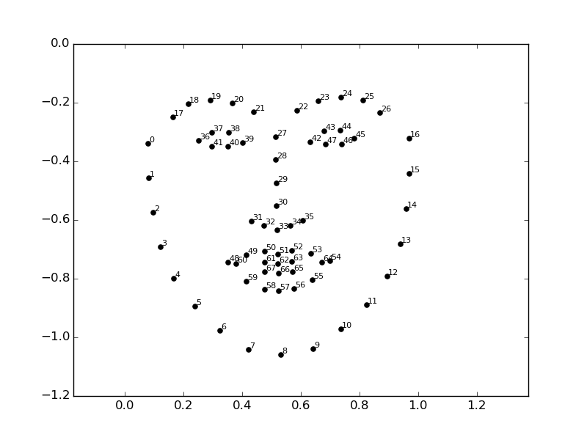
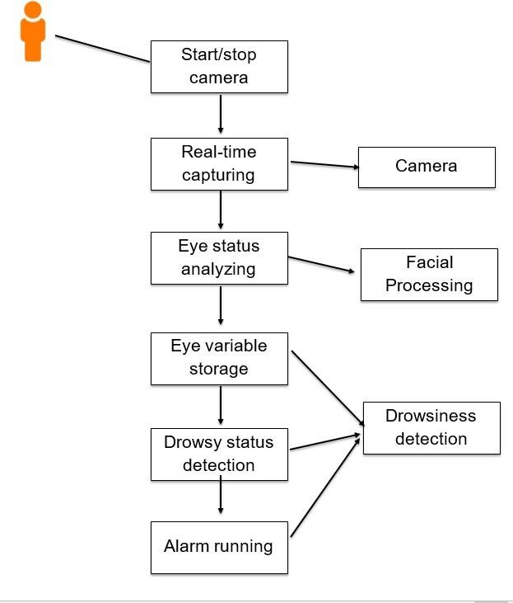
Fig: 1 Use case diagram
For this system, the face and eye classifiers are required. OpenCV is used for the capturing of images, dlib library for the mapping facial parameters and calculating the aspect ratio, and pygame for alerting the person.

The proposed system comprises of three phases.
Face Detection:
As well-known OpenCV is the one of the standard technologies which is used to take computer vision in this project it is used take images or capturing frames in real time video. The proposed system will start by capturing the video frames one by one. The system will detect the face in the frame using dlib library. Then the system maps the 68 standard facial landmarks from the shape predicator of dlib module.

EAR detection:
It is the second stage of the project after the mapping of facial landmarks are completed. In this stage, the landmarks of the right eye and left eye are extracted.
Each eye has 6 landmarks 2 bottom and top and also one left and right. These landmarks have particular number from the standard 68 landmarks.
Left eye in the range of 36 to 41 and right eye ranging from 42 to 47 which returns an x,y co-ordinates that will be used to calculate Eye aspect Ratio.

Drowsiness Detection:
The aspect ratio has a range after which the person considered to be closing eyes. If the ratio passes the maximum threshold (Standard aspect ratio is 3) the person is considered drowsy if the aspect ratio passes the maximum. The score is maintained based on the persons state which will be later used to determine whether person is feeling drowsy or not. If the score passes a value which is to be considered drowsy then an alert is sent to the user to make the person aware of the drowsy feeling.

HARDWARE/SOFTWARE REQUIREMENTS

Hardware requirements:

- 8 GB RAM
- Camera
- 256 GB of storage
- Intel i5 8th gen processor.

Software requirements:

- Python
- OpenCV
- dlib
- pygame

REFERNCES

- Bradski, G. (2000). The OpenCV Library. Dr. Dobb&#x27;s Journal of Software Tools.
- Anil Kumar Biswal, Debabrata Singh, Binod Kumar Pattanayak, Debabrata Samanta, Ming-Hour Yang, "IoT-Based Smart Alert System for Drowsy Driver Detection", Wireless Communications and Mobile Computing, vol. 2021, Article ID 6627217, 13 pages, 2021.
- Davis E. King. Dlib-ml: A Machine Learning Toolkit. Journal of Machine Learning Research 10, pp. 1755-1758, 2009
- PyGame Documentation | Documentation from PyGame Developer Community | https://www.pygame.org/docs

PANEL MEMBERS COMMENTS (ACCEPTED/REJECTED/SUGGESTED FOR CHANGE)

Signature of the Panel Members
1.
2.
3.
4.
5.

Signature of Guide

COORDINATOR HOD

